- \Operation\Monitoring, booklet in carton\Monitoring, booklet in carton
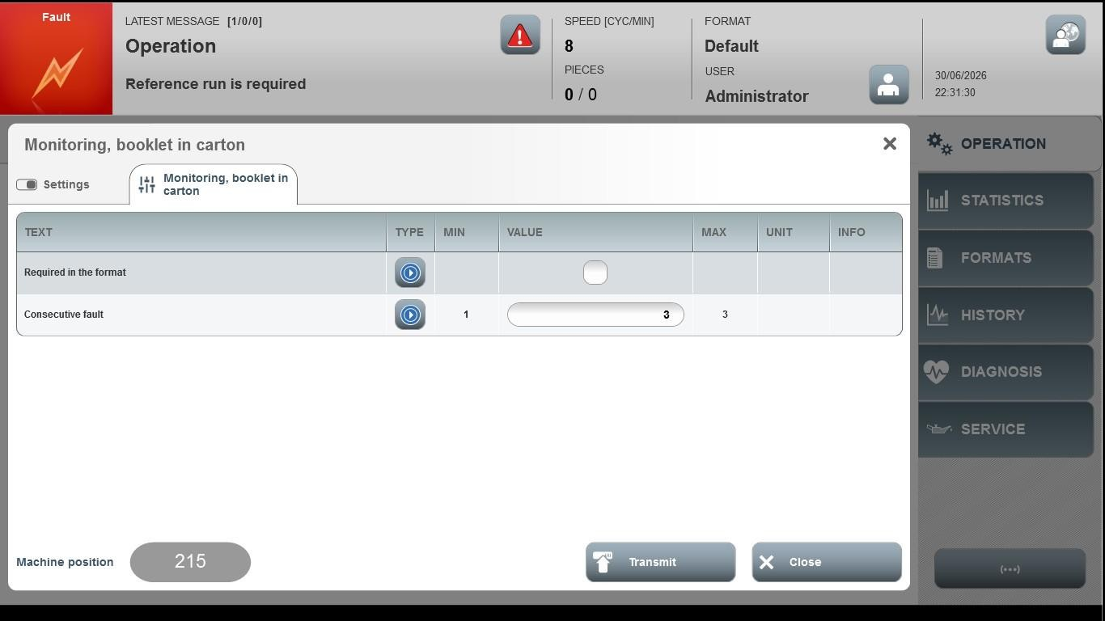
Acceptance criterion | Limits | Pass / Fail: Dev-No. | Date | Initials
Screen matches screenshot | N / A
Consecutive fault | 1 … 3

